## Lab 01 – Sodbileg Shirmen – 610170

Exercise 1:

▪ Performance

* Caching for repeating operations such accessing to database/file system
* Write algorithms with less time/space complexity (BigO)
* Use load balancers

▪ Scalability

* Use distributed systems such cluster technology
* Use microservices for independent each other
* For able to create replica use stateless microservices

▪ Availability

* Use load balancers
* Use backup
* User recovery services

▪ Maintainability

* Follow the design principles
* Use testing

▪ Reliability

* Use microservices and check their health
* If their health fails, use service discovery
* Use failover strategy

Exercise – 2:

A) Draw the context diagram of the financial risk system

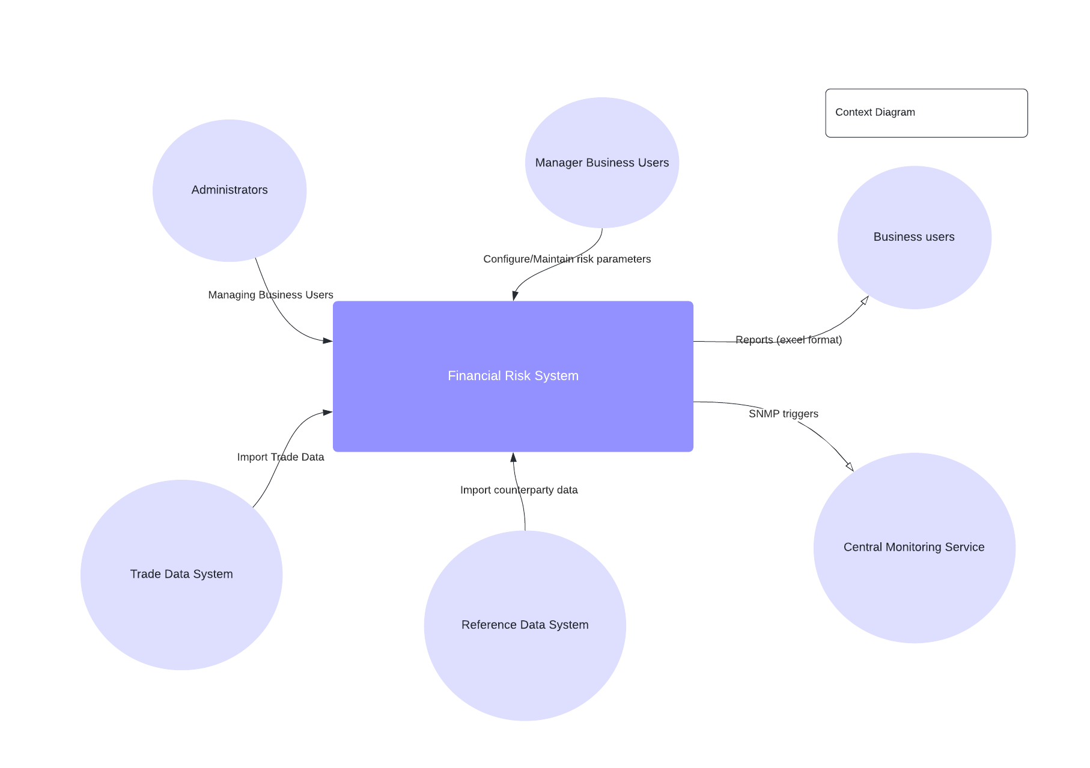

B) Draw the container diagram of the financial risk system:

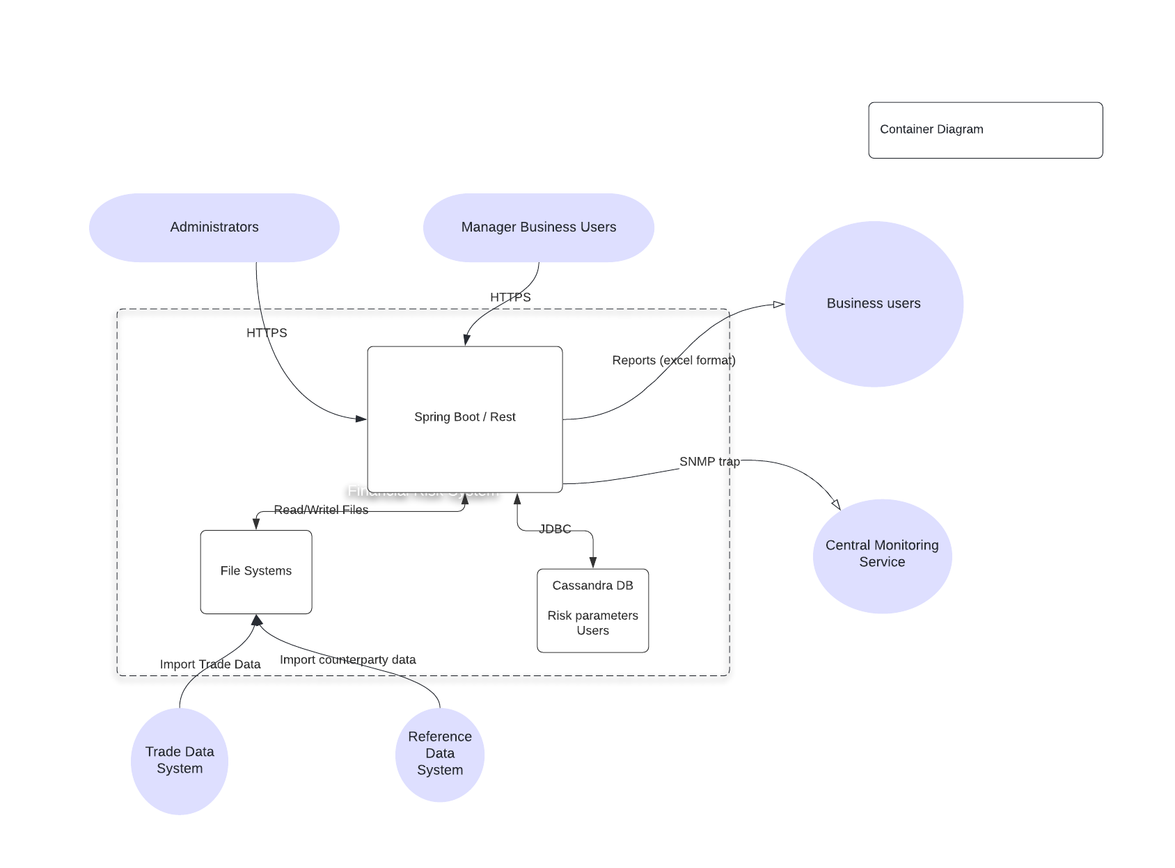

C) Draw the component diagram of the financial risk system

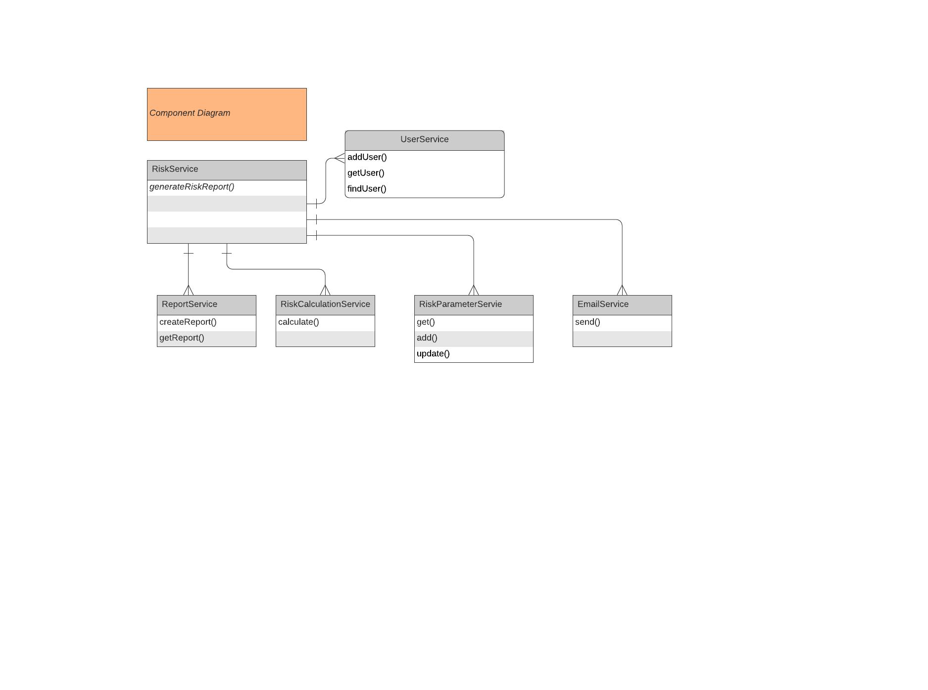

D) Draw the sequence diagram that shows the behavior of the components. The sequence diagram should show the scenario of the creation of a risk report.

